I-55 Improvements
at airport road/Lockport Street
and at il 126

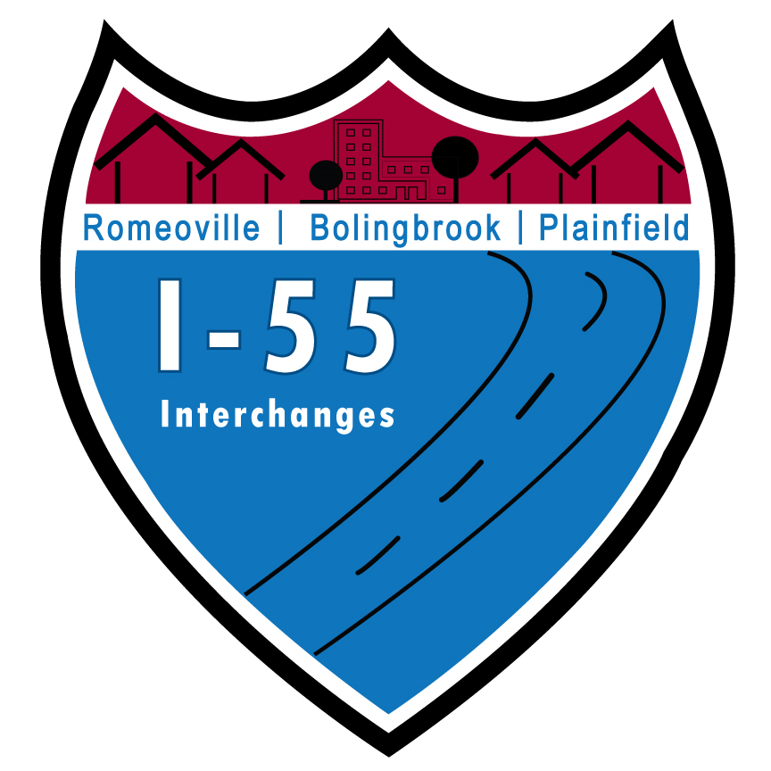

Public Hearing COMMENT SHEET
We invite you to submit comments about the project at the public HEaring or by mail to the address on the back. Comments are welcome at any time, but to be included in the Public HEARING Record, comments must be received by October 16, 2024

FOR More information on the study, please vist the study website: www.airportand126study.ORG

General Comment/Input:
_________________________________________________________________________________________________________________________________________________________________________________________________________________________________________________________________________________________________________________________________________________________________________________________________________________________________________________________________________________________________________________________________________________________________________________________________________________________________________________________________________________________________________________________________________________________________________________________________________________________________________________________________________________________________________________________________________________________________________________________________________________________________________
____________________________________________________________________________________________________________________________________________________________________________________________________________________________________________________________________________________________________________________________________________________________________________________________________________________________________________________________________________________________________________________________________________________________________________________________________________________________________________________________________________________________________________

Please provide your name if you would like to be added to the mailing list or if you would like a response.

Name: _____________________________________________________________
Address: ___________________________________________________________
City/State/Zip: ______________________________________________________
Phone: ____________________________________________________________
E-mail: ____________________________________________________________

Place
Stamp
Here

Illinois Department of Transportation
Bureau of Programming
Attn: Anna Kutryn, P.E.
201 W. Center Court
Schaumburg, IL 60196-1096

